Managing a Complex Aircraft Systems Investigation
Barry Holt – Western Region Senior Technical Investigator – Transportation Safety Board of Canada
David Fisher – Manager, Air Safety Investigations – Commercial Aircraft, Bombardier Air Safety Investigation
Barry spent 15 years in the field as an AME mostly on light and heavy helicopters, and as a Base Engineer for a remote mountain helicopter facility. He joined the Canadian Coast Guard as the Senior Engineer and hoist operator on a Sikorsky S61N. He left the continuous rain and fresh seafood for Edmonton and Transport Canada - Enforcement Branch for a short time before escaping to the TSB in 2001. He is a Certified Aircraft Accident Investigator, training at Southern California Safety Institute and others. He was the IIC for the investigation that he and David will be speaking about today.
David is both a licensed pilot(1978) and an Aircraft Maintenance Engineer since 1982. He started at de Havilland, now Bombardier Aerospace, in 1985, after a number of years in Production, Customer Support Engineering - aging aircraft DHC-1 thru DHC-7. He joined the Aircraft Safety Investigations office 1995. He is a Certified Aircraft Accident Investigator, training at the Southern California Safety Institute and the University of Southern California.
This paper will discuss the many challenges that were experienced during the investigation, and the solutions that were put in place. The investigation had participants from the operator, Bombardier Aerospace Commercial Division, UTC Aerospace Systems, Transport Canada and of course the TSB of Canada.
On 6 November 2014, Jazz Aviation Flight 8481 departed Calgary International for Grande Prairie, Alberta, with 71 passengers and 4 crew. During take-off, the #3 tire failed. The flight diverted to Edmonton International due to strong crosswinds at Calgary. Once at Edmonton, they were to change aircraft and continue to Grande Prairie. In subsequent flight crew conversations with maintenance personnel, it was recommended that the flight crew perform a “soft” landing due to the tire failure. No emergency was declared, nor was aircraft rescue and firefighting (ARFF) equipment requested. However, the equipment did roll out to meet the aircraft during the landing. Preparations were then made for a normal landing, as there was no reason or cause for concern to land with one flat tire. However, 2.3 seconds after initial touchdown, at 2030 Mountain Standard Time, and at 2435 feet from the threshold, the right main landing gear (MLG) collapsed. Upon contact with the ground, all of the right-side propeller blades were sheared, and 1 blade piece penetrated the right side of the cabin wall. The aircraft came to rest about 3200 feet later, off the right (east) edge of the runway surface. Thankfully there were only a few minor injuries.
The aircraft was recovered to a hangar the next morning for testing and initial inspection. In the meantime, the Transportation Safety Board of Canada (TSBC) asked the aircraft manufacturer, Bombardier, to assist in the initial investigative phase. A Senior Air Safety Investigator dispatched along with a Bombardier, In-Service Engineer. Additionally, the Operator (Air Canada Jazz) dispatched an investigator as did the landing gear manufacturer (UTAS) United Technology Aeronautical Systems (Goodrich Landing Gear). The initial investigation did not reveal any substantial findings and it was evident from the first few days of the investigation that there appeared to be nothing wrong with the landing gear system as it operated normally on jacks, and all components appeared to be within all design specifications.

After approximately one week, it was decided to convene a second team, which included the Manager, Bombardier Air Safety Investigations Office. Also 4 additional Bombardier Engineering representatives attended – an electrical engineering specialist, a Hydraulic Specialist, a DAD Landing Gear Specialist and a Q400 Specialist - Engineering. Also assisting was the Operator, UTAS and Transport Canada.

During the second team visit, all associated wiring components were tested in detail, and the proximity sensor electronic unit (PSEU) was checked for all faults recorded. Numerous components where removed from the aircraft for additional testing. This included an electrical connector (P23) located in the fuselage to wing attachment area that supplies 28VDC to the landing gear Solenoid Sequence Valve (SSV). In addition, the Main Landing Gear Cockpit Selector Handle Assembly, PSEU and the landing gear assembly including the landing gear drag brace, landing gear main strut, main landing gear yoke and the horizontal stabilizer brace including the proximity sensors and the hydraulic unlock actuator.

Data from the aircraft’s digital flight data recorder (DFDR) was analyzed at the TSB Engineering Laboratory. The focus of the analysis was on the takeoff roll, when the tire failed, and on the subsequent collapse of the right MLG on landing. The DFDR had recorded tri-axial accelerations, which provided information on the aircraft vibrations when the tire failed. The landing gear data consisted of a number of discrete signals that indicated the status of the up-locks and down-locks for the nose landing gear and MLGs, the landing gear handle position, and the weight-on-wheels (WOW) state. A momentary MLG WOW was recorded at 118 knots, with the recorded vertical load factor at approximately +1.05g. Approximately 1.5 seconds later, full MLG WOW recorded a vertical load factor of +1.07g. This is an indication of very light touchdown forces and a soft landing, which we found would somewhat come into play later.

Investigators initially travelled to the wheel manufacturer’s facility to determine the level of imbalance on the wheel. The #3 wheel and tire assembly had an imbalance of 1248 ounce-inches, or 6.5 lb. 12 inches from the wheel centre. The team then met later at the landing gear manufacturer’s facility to conduct full measurements of the main components that may have allowed to collapse to occur. At this time, there was a lot of second-guessing by some to suggest the impossibility of the failure of various components.
There was still an ongoing resistance when some engineers were stuck on the idea that this could not happen, when in fact it did. A meeting was convened in January of 2015, at the aircraft manufacturer’s facility located in Toronto, Ontario, Canada. This is when a determined effort had to be put forth by the IIC and the Manager of Bombardier Commercial Air Safety Investigations. Both pushed the fact that the failure had occurred and that the root cause had to be found. This was the purpose of the TSB investigation, and the sole reason for all of the team to be there. The IIC had to manage all of the various individuals’ issues and ensure that the goal of the investigation was accomplished. The Bombardier Manager pushed hard on his organization’s management to ensure that this goal was understood and to have full co-operation of the Bombardier investigation team members. Some had participated in the design acceptance during the airframe planning stages. This also required the buy in of all team members from UTC Aerospace, who had designed and manufactured the landing gear. Upper management of UTC then stepped forward with the full use of their personnel and facility to conduct the testing. An investigation plan had to be developed that encompassed all parts of the landing gear system and its control.
The schedule was moving forward at a reasonable pace and we believed testing could be begin in the summer of 2015. However, on March 8th 2015 things were about to change.
Bombardier Air Safety Investigations Office received a report that a Spice Jet Q400 experienced a runway excursion after landing in darkness and rainy conditions. The aircraft was reported to have hit a runway light and departed the left side of the runway, the Nose Landing Gear and Left Main Landing Gear collapsed. The aircraft was substantially damaged. There were no injuries to crew or passengers. The location of the accident was Hubli, India. We knew that this was the first flight into Hubli Airport after the airport had under gone improvements to the airport and runway including a new runway lighting system.
Bombardier dispatched a Field Service Representative (FSR) to assist in the aircraft recovery. Bombardier Air Safety Investigations contacted the FSR and requested detailed pictures of the damaged aircraft and specifically the landing gear. The aircraft was off the left side of the runway and substantially damaged, but accessible.
Upon receiving the picture’s it was immediately noted that left main landing gear, aft doors were open, all other doors closed and in their proper position for a normal landing. This was not expected; the Manager immediately forwarded this information to the TSBC.
This second event suddenly put extreme pressure on the investigation team. Internal to the manufacturer they faced additional pressures from upper management, aircraft operators and the regulator. The team needed to answer, why after 15 years of production and 12 million-flight hours, we have had two unexplained landing gear collapses after otherwise “normal” landings. Certainly, having a blown tire and hitting a lighting light are not-unforeseen events. Aircraft experience these events in normal service life. Why now?

Following an again revised plan involved a full examination of the Horizontal Stabilizer Brace for dimensional correctness as per the design. It was found to be correct and within acceptable wear limits. It was set aside in order to test some of the smaller components and to allow time to design a test rig for the brace.
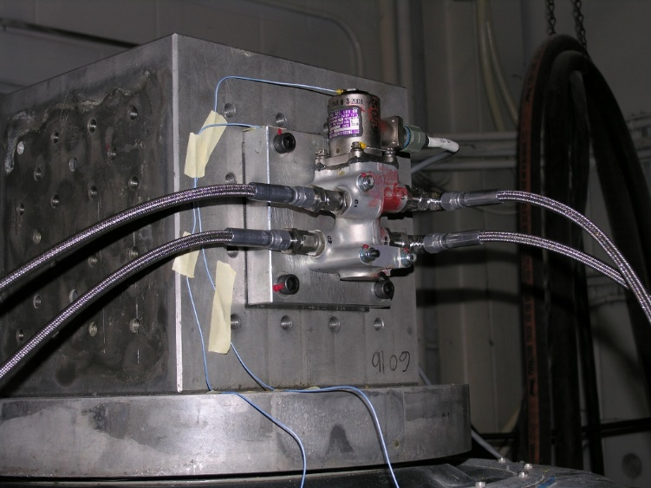
The Solenoid Sequence Valve (SSV) was bench checked and found to be within design parameters. A test rig was then designed to test its function during dynamic vibrations. This was a full 2 days at increasing vibration levels and at decreasing voltages, to ascertain when the SSV would release hydraulic pressure to the aircraft lock actuator. This type of testing had not been done during development. The component was first tested for function, put through vibration sequences, and then function tested again. Throughout all this there was much discussion and speculation about the ultimate outcome as it related to the effect(s) on the landing gear collapse. There had to be a concerted effort by the lead investigators to keep the end result in mind and on target.
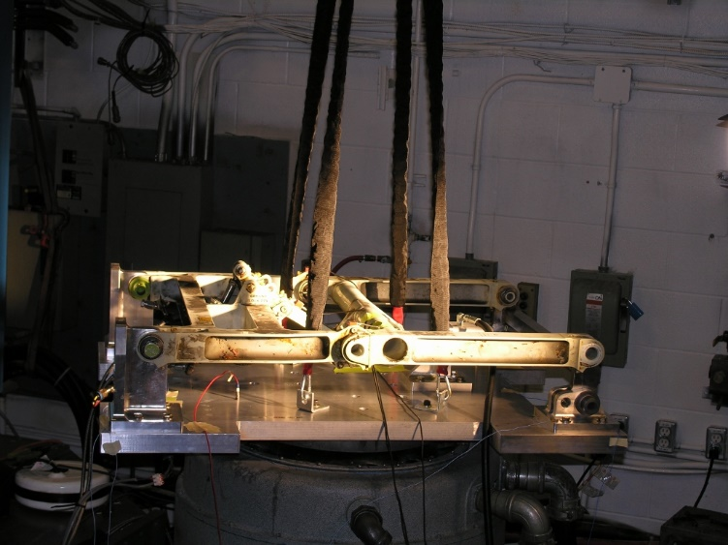
Next, the Horizontal Stabilizer Brace underwent the same sequence of testing to see if vibration could induce a loss of the locked state. As the vibration frequencies and amplitude approached what was seen on the accident aircraft, some of the investigation group could see a noticeable vibration. Many members could not see or admit to this happening. Most of those were from various design groups. Once again the difficulties in leading a complex investigation with many differing priorities came to life. The lead investigators had some convincing to do to move forward with full-scale landing gear tests.
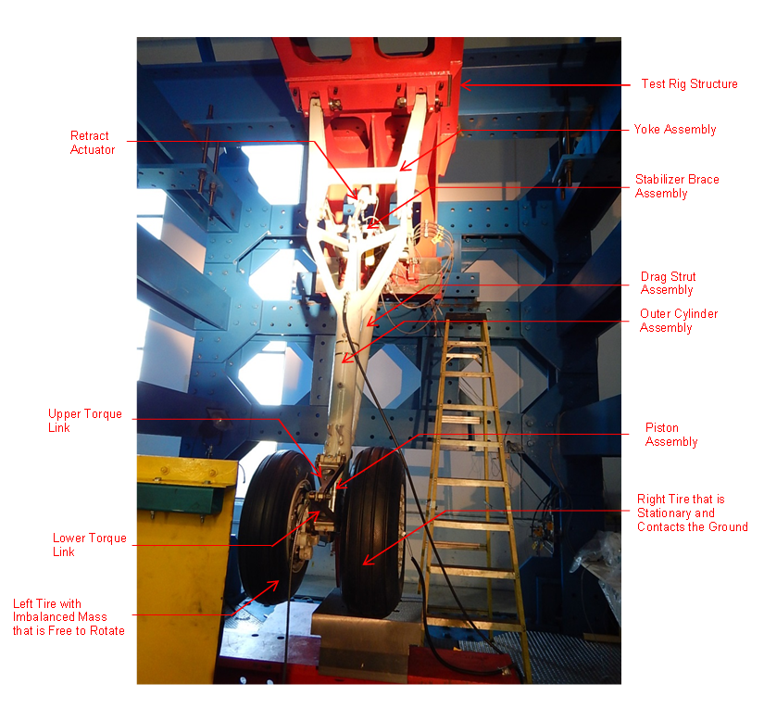
Bombardier and UTAS then agreed to develop a full-scale landing gear test rig in order examine the behavior of the Landing Gear, Solenoid Sequence Valve and Horizontal Stabilizer Brace and PSEU during concurrent vibrating and dynamic conditions. This process and testing was also not a certification requirement and had never been done before. Exploration of possible investigative techniques and allowances to simulate the actual landing conditions were examined at length. Testing models of all the involved components were developed and agreed to by all attached to this part of the investigation. The imbalance and resulting vibration that had occurred had to be factored in and test run protocols established. A full landing gear test rig had to be designed and agreed to by all the principal team members. This was a challenge however everyone pulled together and channeled their efforts into the one goal.
The MLG assembly test rig included:
- A modified A380 test cell structure.
- A hydraulic system that enabled independent pressurization of MLG retract and unlock actuators.
- Proximity sensors inductance acquisition card.
- 2 and 3-axis accelerometers.
- A data acquisition system.
- High speed and standard cameras and video systems.
- A spin-up machine.
Testing was designed to be slow and progressive. No one was certain how the test rig would perform. After the initial tests with a very light imbalance weight, most of the team were shocked at the amount of twisting and movement of the gear. Concerns were raised about the possibility of catastrophic breakage of some of the components. The engineers went back to their modelling programs based on the initial runs.
There were 4 more test sessions conducted at UTC in Oakville, Ontario during the simmer of 2015. Each was 3 to 4 days in duration. There were a couple of times when testing had to be stopped due to the breakage of components in the test structure or the need to modify some parts of the test rig. The breakage was thought to occur due to the stiffness of the rig vs. being mounted in a nacelle “on wing”, which would have been less rigid but impossible to do. One such time, with the rigidity of the structure, the upper (forward) drag brace fixture fractured.
After the upper drag brace fixture was repaired, the team repeated the same test, with hydraulic system pressure (3,000 psi) on the unlock actuator. High-speed cameras and videos were all in place and the test began. This test revealed that when normal hydraulic pressure was applied at the unlock actuator, the stabilizer brace would remain down and locked.
There were over 70 runs conducted. In the end and as it turned out, the gear unlocked under the same conditions (no hydraulic pressure on the unlock actuator) as were encountered during the landing phase of the accident. There was a great amount of jubilation when we found that we had accurately replicated the accident conditions and achieved a same result. The team continued to test different configurations including lesser stabilizer brace over-center conditions and oleo compression; however, during a later test with full oleo compression, both the drag brace shear pin and the spin-up machine broke. We had broken our rig for good, but we did have all the data needed to come out with important modifications to several components of the gear.
The team determined that in order to accommodate for a highly imbalanced tire or a single impulse event hydraulic pressure would need to remain on the unlock actuator at all times. This could be solved by a simple modification to the current PSEU logic.
Early PSEU’s could be modified by a software upgrade and new aircraft starting at production serial number 4554 would be equipped with a new -602 PSEU. Airworthiness Directive CF-2016-31 was introduced and PSEU’s modified.
The TSB investigation encompassed more than just the landing gear and imbalance testing that taken place. Operations personnel verified that the flight crew had done everything correctly. The failure mode of the tire itself had to be ascertained. The operator’s maintenance records and cabin crew training was reviewed. Cabin egress was looked into and reported on. Edmonton International Airport emergency response programs were looked at and the handling of the passengers post-egress. This required the bringing together of an investigation team with various and diverse backgrounds, such as electrical, avionics, design and manufacture, tire design and failure modes, maintenance and operations. All of these links were from different organizations and departments within those organizations.
The team had explored and accomplished many possible and different investigative techniques:
- Involvement of many different engineers from numerous manufacturers
- A never done before vibration analysis and testing methodology
- Technical review
- Results and dissemination to the aviation world
In spite of the complexities and time required, the investigation resulted in worldwide changes to the Q400 fleet landing gear. It really did make a difference.

